IEEE Transactions on Industry Applications

Dear Mr. Hoerauf,

Kindly find attached revised manuscript entitled “Ultrafast Transmission Line Fault Detection Using a DWT Based ANN” in which I am responding to the comments raised by the reviewers.

I agree with the reviewer’s comments and replied to all their comments within the revised manuscript. The replies are separately attached in the reply sheet.

Finally, I hope you and the reviewers find the paper enjoyable as I found it during preparation, simulation, writing and proof reading.

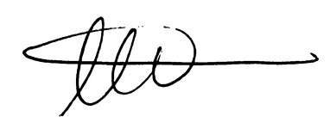

Ahmad Abdullah

Power System Design Engineer

Electric Power Engineers Inc.,

Austin, TX, 78738